DECLARATION OF ORIGINALITY

We hereby certify that we are the sole author of this project and that neither any part of this work nor the whole work has been submitted for a degree to any other University or Institution.

We certify that, to the best of our knowledge, our work does not infringe upon anyone’s copyright nor violate any proprietary rights and that any ideas, techniques, quotation, or any other material from the work of other people included in our report or otherwise, are fully acknowledged in the accordance with the standard referencing practices.

We declare that this is a true copy our report, including any final revisions, as approved by our supervisor.

**Date:**

**Place:** Surat

**Yours Sincerely,**

Kansara Parth (206120316024)

Kansara Prashant(206120316025)

Rana Prem(206120316036)

ACKNOWLEDGEMENT

The success and final outcome of this project required a lot of guidance and assistance from many people and we are extremely privileged to have got this all along the completion of our project. All that we have done is only due to such supervision and assistance and we would not forget to thank them.

We heartily thank our internal project guide, **Mr. Chintan A. Gajjar (Lecturer in I.T. Department),** for his guidance and suggestions during this project work. We would not forget to remember **Mr. J. R. Mahida** for his encouragement and more over for his timely support and guidance till the completion of our project work. The project would not have been successfully completed without continuous support, motivation extended by our colleagues and friends who were always with us whenever we needed.

We are thankful to and fortunate enough to get constant encouragement, support and guidance from all Teaching staffs of **I.T. Department** which helped us in successfully completing our project work.

Last but not least, thanks to **Dr. S & S. S. Ghandhy College of Engineering & Technology** for providing us the platform to represent the project.

**Yours Sincerely,**

Kansara Parth (206120316024)

Kansara Prashant(206120316025)

Rana Prem(206120316036)

**Abstract**

Timetable Management solves the clash of schedules for each faculty member by semester and batch.

**PROJECT PROFILE:**

**Project Title:** Time Table Management

**Project Type:**

**Front-End:**

**Operating System:** Windows 8.0 or above

**Back-side Language:**

**Project Guide:** Chintan Gajjar

**Submitted By:**

**Submitted To:** Dr. S & S.S. Ghandhy College of Engineering & Technology, Surat

Table of Contents

**Declaration of Originality I**

**Acknowledgement II**

**Abstract III**

**Project Profile IV**

**Chapter-1 Introduction1**

1.1 Project definition 2

1.2 Scope of the project 2

**Chapter-2** **System Requirement study4**

2.1 Problem of existing system 5

2.2 Requirement of proposed system 5

2.3 Project Life Cycle Model 7

2.4 Software Requirement Specification 7

**Chapter-3 System Design10**

3.1 E-R Diagram 11

3.2 Data Flow Diagram 12

3.3 Data Dictionary 13

**Chapter-4 UML 21**

4.1 Use case Diagram 22

4.2 Activity Diagram 23

**Bibliography 26**

List of Figures

Fig. 1.1 Schematic Diagram**2**

Fig. 1.2 Architecture **8**

Fig 2.1 Basic Security Model**11**

Fig 3.1 Proposed systems E-R Diagram**15**

Fig 3.2 Context Level Diagram**17**

Fig 3.3 Level-1 Dataflow Diagram**18**

Fig 3.4 Level-2 Dataflow Diagram**19**

Fig 4.1 Use case Diagram**20**

Fig 4.2 Activity Diagram**21**

List of Tables

Fig 2.1 Latest Framework and Methodology**13**

Fig 4.1 Keys for Encryption**17**

Fig 4.2 Observation Table**19**

**Introduction**

**Project definition:**

* Time table management is software that provides an easy way to clash from the faculty time table and show the schedule of class/lab faculty.

**Scope of the project:**

* Time table management is software that can find cohesion in an imputed time table.
* It shows class occupancy and lab occupancy.

**Project Life Cycle Model:**

**// water fall**

**System Requirement study**

**Problem of existing system:**

* In the Education Institute, creating a timetable is a tedious task so that sometimes by mistake in the time table two different classes have one faculty or two different faculty in one class.

**Requirement of proposed system:**

* Nowadays there is no computerized system to show the faculty’s timetable.
* We are making a small approach to making cohesion between faculty’s time and gives an immediate result of timetable and it will store it till we want.

**Software Requirement Specification**

* Time table management has two Features first one is create new and second one open exiting.
* Create new is create new empty input filed where you can enter your timetable.
* For input department by giving department_code and department_name.
* Input timetable faculty by giving faculty_code, faculty_name, type and subject.
* Input subject by giving subject_code, subject_name.
* Input room by giving class_division and lab_batch.
* Input time sloat.
* After inputting timetable it finds Cohesion and displays it.
* At the end it store timetable which you can access after later.
* Second one is open exiting you can open previously stored time table.
* It finds cohesion from inputted time table.
* It also displays class occupancy and lab occupancy.

**System Requirement study**

**E-R Diagram:**

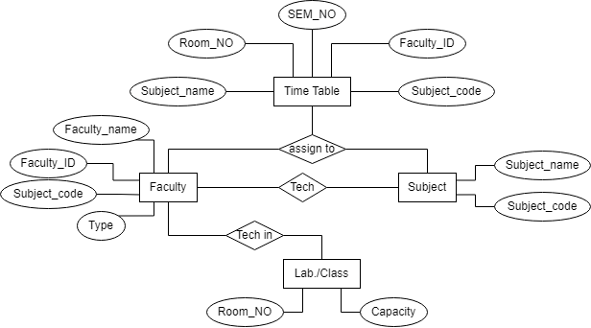

**Data Flow Diagram:**

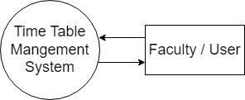

**Level-0**

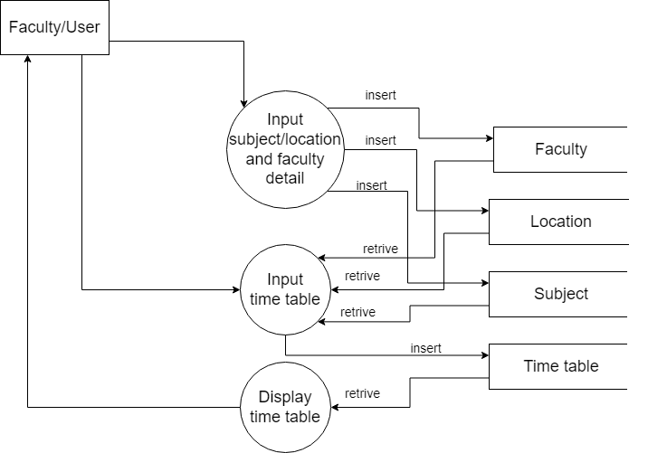

**Level-1**

**Data Dictionary:**

**Time Table:**

|  |  |  |  |  |
| --- | --- | --- | --- | --- |
| **Field** | **Type** | **Null** | **Key** | **Description** |
| Timetable_Id | Int(10) | NO | PRI | Unique ID of timetable |
| SEM | Int(10) | NO |  | Represent Timetable’s SEM |
| Faculty_ID | Int(10) | NO | FOR | Represent Faculty’s ID |
| Subject_ID | Int(10) | NO | FOR | Represent Subject’s ID |
| Room_ID | Int(10) | NO | FOR | Represent Room’s ID |

**Facility:**

|  |  |  |  |  |
| --- | --- | --- | --- | --- |
| **Field** | **Type** | **Null** | **Key** | **Description** |
| Faculty_ID | Int(10) | NO | PRI | Unique ID of faculty |
| Faculty_name | Varchar(50) | NO |  | Name of faculty |
| Subject_ID | Int(10) | NO | FOR | Represent Subject’s ID |
| Type | Varchar(10) | NO |  | Type of faculty |

**Subject:**

|  |  |  |  |  |
| --- | --- | --- | --- | --- |
| **Field** | **Type** | **Null** | **Key** | **Description** |
| Subject_ID | Int(10) | NO | PRI | Represent Subject’s ID |
| Subject_code | Int(6) | NO |  | Code of subject in GTU |
| Subject_name | Varchar(50) | NO |  | Name of subject |

**Class/lab:**

|  |  |  |  |  |
| --- | --- | --- | --- | --- |
| **Field** | **Type** | **Null** | **Key** | **Description** |
| Room_ID | Int(10) | NO | PRI | Unique ID of Class/lab |
| Capacity | Int(3) | NO |  | Total Student capacity of class/lab |

**UML**

**Use case Diagram:**

**Activity Diagram:**

